Program: SE Electrical Engineering
Curriculum Scheme: Revised 2016
Examination:
Course Code: EEC603 and Course Name: Electrical network
Time: 1hour Max. Marks: 50
==============================================================================
Note to the students:- All the Questions are compulsory and carry equal marks .
Q1. | The Superposition Theorem is not applicable for _________
Option A: | Power calculation
Option B: | Voltage calculation
Option C: | Current Calculation
Option D: | Both Voltage and Current calculation
Q2. | In superposition theorem when we consider one voltage source, all the other voltage sources are ___________
Option A: | Shorted
Option B: | Removed
Option C: | Undisturbed
Option D: | Opened
Q3. | The current I in the circuit given below is ________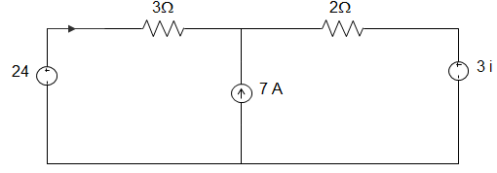
Option A: | 1/4 A
Option B: | 5/4 A
Option C: | 3/4 A
Option D: | 1/2 A
Q4. | In Reciprocity Theorem, which of the following ratios is considered?
Option A: | Voltage to current
Option B: | Current to current
Option C: | Voltage to voltage
Option D: | No ratio is considered
Q5. | The Reciprocity Theorem is valid for ___________
Option A: | Non-Linear Time Invariant circuits
Option B: | Linear Time Invariant circuits
Option C: | Non-Linear Time Variant circuits
Option D: | Linear Time Variant circuits
Q6. | The Reciprocity Theorem is applicable for __________
Option A: | Single-source networks
Option B: | Multi-source networks
Option C: | Both Single and Multi-source networks
Option D: | Neither Single nor Multi-source networks
Q7. | In the circuit given below, the maximum power absorbed by the load resistance R_{L} is ___________  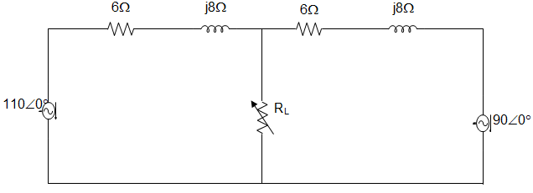
Option A: | 3 W
Option B: | 5.2 W
Option C: | 3.2 W
Option D: | 4.2 W
Q8. | If there are N nodes in a circuit, then the number of nodal equations that can be formed are?
Option A: | N+1
Option B: | N
Option C: | N-1
Option D: | N-2
Q9. | Superposition theorem states that the response in any element is the ____________ of the responses that can be expected to flow if each source acts independently of other sources.
Option A: | algebraic sum
Option B: | vector sum
Option C: | multiplication
Option D: | subtraction
Q10. | Find the voltage across (2+j5) Ω impedance considering 50∠0⁰ voltage source.
Option A: | 30.16∠-9.28⁰
Option B: | 30.16∠9.28⁰
Option C: | 29.16∠-9.28⁰
Option D: | 29.16∠9.28⁰
Q11. | Determine the voltage across (2+j5) Ω impedance considering 20∠30⁰ voltage source.
Option A: | 45.69∠-110.72⁰
Option B: | 45.69∠110.72⁰
Option C: | 46.69∠-110.72⁰
Option D: | 46.69∠110.72⁰
Q12. | Thevenin’s voltage is equal to the _____________ voltage across the _______________ terminals.
Option A: | short circuit, input
Option B: | short circuit, output
Option C: | open circuit, output
Option D: | open circuit, input
Q13. | Determine the Thevenin’s voltage across ‘ab’ terminals in the circuit shown below. 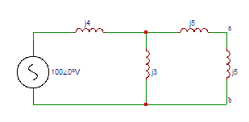
Option A: | 41.86∠0⁰
Option B: | 42.86∠0⁰
Option C: | 43.86∠0⁰
Option D: | 44.86∠0⁰
Q14. | Norton’s current is equal to the current passing through the ___________ circuited ___________ terminals.
Option A: | short, input
Option B: | short, output
Option C: | open, output
Option D: | open, input
Q15. | The condition for maximum voltage to be transferred to the load is?
Option A: | Source resistance greater than load resistance
Option B: | Source resistance less than load resistance
Option C: | Source resistance equal to load resistance
Option D: | Source resistance greater than or equal to load resistance
Q16. | The condition for maximum current to be transferred to the load is?
Option A: | Source resistance greater than or equal to load resistance
Option B: | Source resistance equal to load resistance
Option C: | Source resistance less than load resistance
Option D: | Source resistance greater than load resistance
Q17. | The condition for maximum power to be transferred to the load is?
Option A: | Source resistance equal to load resistance
Option B: | Source resistance greater than load resistance
Option C: | Source resistance greater than or equal to load resistance
Option D: | Source resistance less than load resistance
Q18. | If Z_{S}=R_{S}+jX_{S}, Z_{L}=R_{L}, then condition for maximum power to be transferred is?
Option A: | R_{L}=|Z_{S}|
Option B: | R_{L}=Z_{S}
Option C: | R_{L}=-|Z_{S}|
Option D: | R_{L}=-Z_{S}
Q19. | A series RLC circuit has a resonance frequency of 1 kHz and a quality factor Q = 100. If each of R, L and C is doubled from its original value, the new Q of the circuit is _____________
Option A: | 25
Option B: | 50
Option C: | 100
Option D: | 200
Q20. | .Consider the circuit shown below. Find the current I₁ (A).  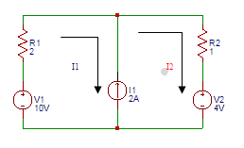
Option A: | 1
Option B: | 1.33
Option C: | 1.66
Option D: | 2
Q21. | In nodal analysis how many nodes are taken as reference nodes?
Option A: | 1
Option B: | 2
Option C: | 3
Option D: | 4
Q22. | Determine the equivalent thevenin’s voltage between terminals A and B in the circuit shown below. 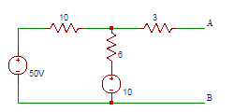
Option A: | 0.333
Option B: | 3.33
Option C: | 33.3
Option D: | 333
Q23. | Determine the equivalent thevenin’s voltage between terminals A and B in the circuit shown below.
Option A: | 0.333
Option B: | 3.33
Option C: | 33.3
Option D: | 333
Q24. | For Z_{L} = Z_{S}*, the relation between X_{L} and X_{S} is?
Option A: | X_{L} = X_{S}
Option B: | X_{L} = 0
Option C: | X_{L} = 1
Option D: | X_{L} = -X_{S}
Q25. | If Z_{L} = Z_{S}*, then?
Option A: | R_{L} = 1
Option B: | R_{L} = 0
Option C: | R_{L} = -R_{S}
Option D: | R_{L} = R_{S}

